**EXP – 3**

**Step 1:**

**Open Cisco Packet Tracer.**

1. **Add devices:**
   * Use switch 2960.
   * Select two or more pc
2. **Connect devices:**
   * Use the Copper Straight-Through cable for connections.
   * Connect each PC to the switch using the FastEthernet ports (e.g., PC0 to FastEthernet0/1, PC1 to FastEthernet0/2).

**Step 2: Configuring the Switch**

1. **Open the CLI (Command-Line Interface) of the switch:**

Click on the switch and go to the CLI tab.

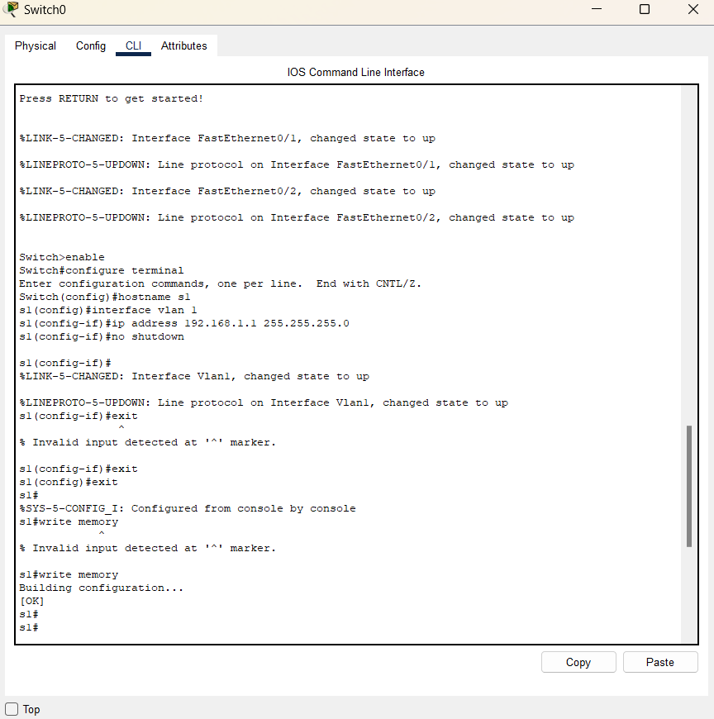

**Router Configuration process**

1. **Enter privileged EXEC mode:**

Switch> enable

Switch#

1. **Enter global configuration mode:**

Switch# configure terminal

Switch(config)#

1. **Configure the switch hostname (optional):**

Switch(config)# hostname s1

S2(config)#

1. **Configure VLAN 1 (default VLAN) interface with an IP address**

S1(config)# interface vlan 1

S1(config-if)# ip address 192.168.1.1 255.255.255.0

S1(config-if)# no shutdown

S1(config-if)# exit

S1(config)#

1. **Save the configuration:**

S1(config)# exit

S1# write memory

**Step 3: Configuring PCs**

1. **Assign IP addresses to PCs:**
   * Click on each PC and go to the Desktop tab.
   * Open the IP Configuration and assign an IP address within the same subnet as the switch's VLAN 1 interface. For example:
     + PC0: IP Address: 192.168.1.2, Subnet Mask: 255.255.255.0
     + PC1: IP Address: 192.168.1.3, Subnet Mask: 255.255.255.0

**Step 4: Testing Connectivity**

1. **Ping between PCs:**
   * Open the Command Prompt on one of the PCs (e.g., PC0).
   * Use the ping command to check connectivity to the other PC (e.g., ping 192.168.1.3).

